**DAILY ONLINE ACTIVITIES SUMMARY**

|  |  |  |  |  |  |  |  |  |
| --- | --- | --- | --- | --- | --- | --- | --- | --- |
| **Date:** | **27/06/2020** | | | | | **Name:** | **Lavanya D M** | |
| **Sem & Sec** | **4th & ‘A’** | | | | | **USN:** | **4al18cs041** | |
| **Online Test Summary** | | | | | | | | |
| **Subject** | | **Data Communication** | | | | | | |
| **Max. Marks** | | **30** | | **Score** | | | **24** | |
| **Certification Course Summary** | | | | | | | | |
| **Course** | EIGRP Course | | | | | | | |
| **Certificate Provider** | | | **Bitdegree** | | **Duration** | | | **1week** |
| **Coding Challenges** | | | | | | | | |
| **Problem Statement:**  1) Write a C program to print kth digit   |  | | --- | |  |   2) Write the C++ program to find the sum of the diagonals | | | | | | | | |
| **Status: Complied** | | | | | | | | |
| **Uploaded the report in Github** | | | | | **yes** | | | |
| **If yes Repository name** | | | | | <https://github.com/lavanyamurthi/lockdown-coding> | | | |
| **Uploaded the report in slack** | | | | | **yes** | | | |

Online Test Details: (Attach the snapshot and briefly write the report for the same)

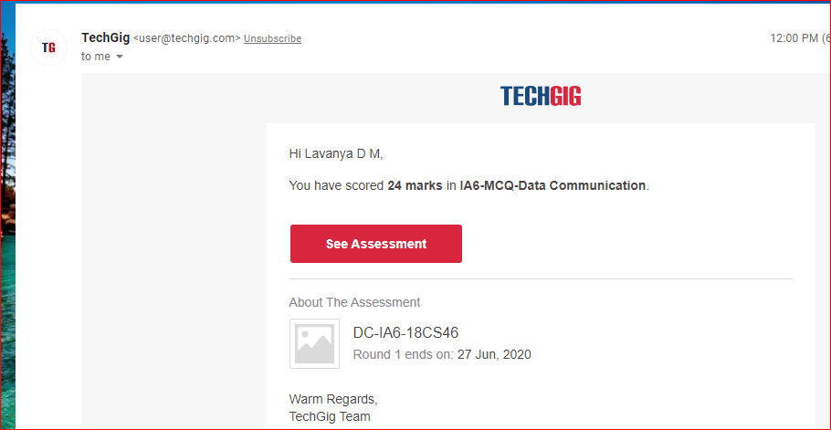

Webinar:

Today class is conducted on Cyber security by Megha ma’am in which we learn about the concept of programming , and even we had quiz regarding that

Certification Course Details: (Attach the snapshot and briefly write the report for the same)

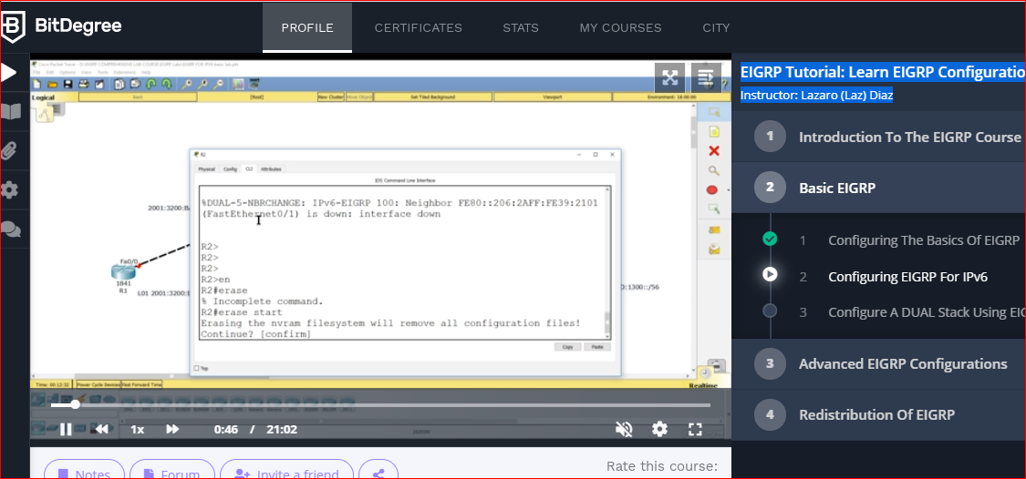

Coding Challenges Details: (Attach the snapshot and briefly write the report for the same)

**Problem 1** : Write a C program to print kth digit

Given two numbers a and b, find kth digit from right of a^b.

Input:

The first line of the input contains T denoting the number of test cases.Each of the next T lines contains three space separated positive integers denoting the value of a , b and k respectively.

Output:

For each test case, output the kth digit from right of a^b in new line.

Constraints:

1<=T<=100  
1<=a , b <=15  
1<=k<=|totaldigits in a^b|

Example:

Input:  
2  
3 3 1  
5 2 2

Output:  
7  
2

Hint  
Output: 1  
Explanation 3^3 = 27 for k = 1. First digit is 7 in 27  
Output : 2  
Explanation 5^2 = 25 for k = 2. First digit is 2 in 25

|  |
| --- |
|  |
|  |  |

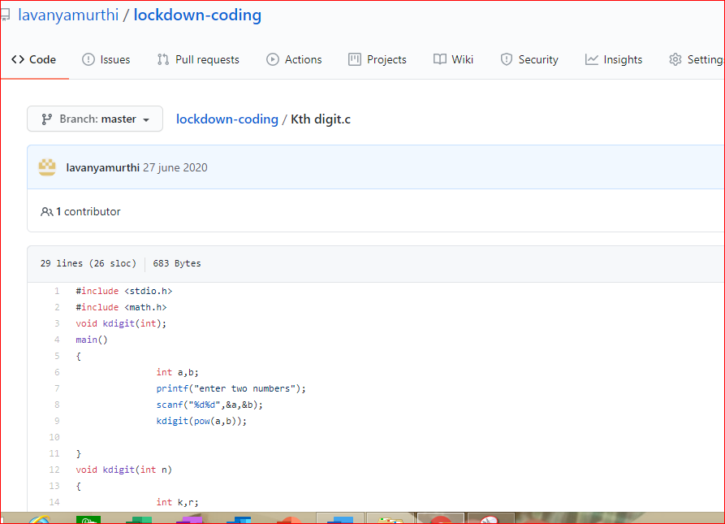

**Problem 2:**  Write the C++ program to find the sum of the diagonals

